Arrival at Schiphol Airport
In the very large central arrivals hall, you buy a train ticket (single) to Station Ede-Wageningen
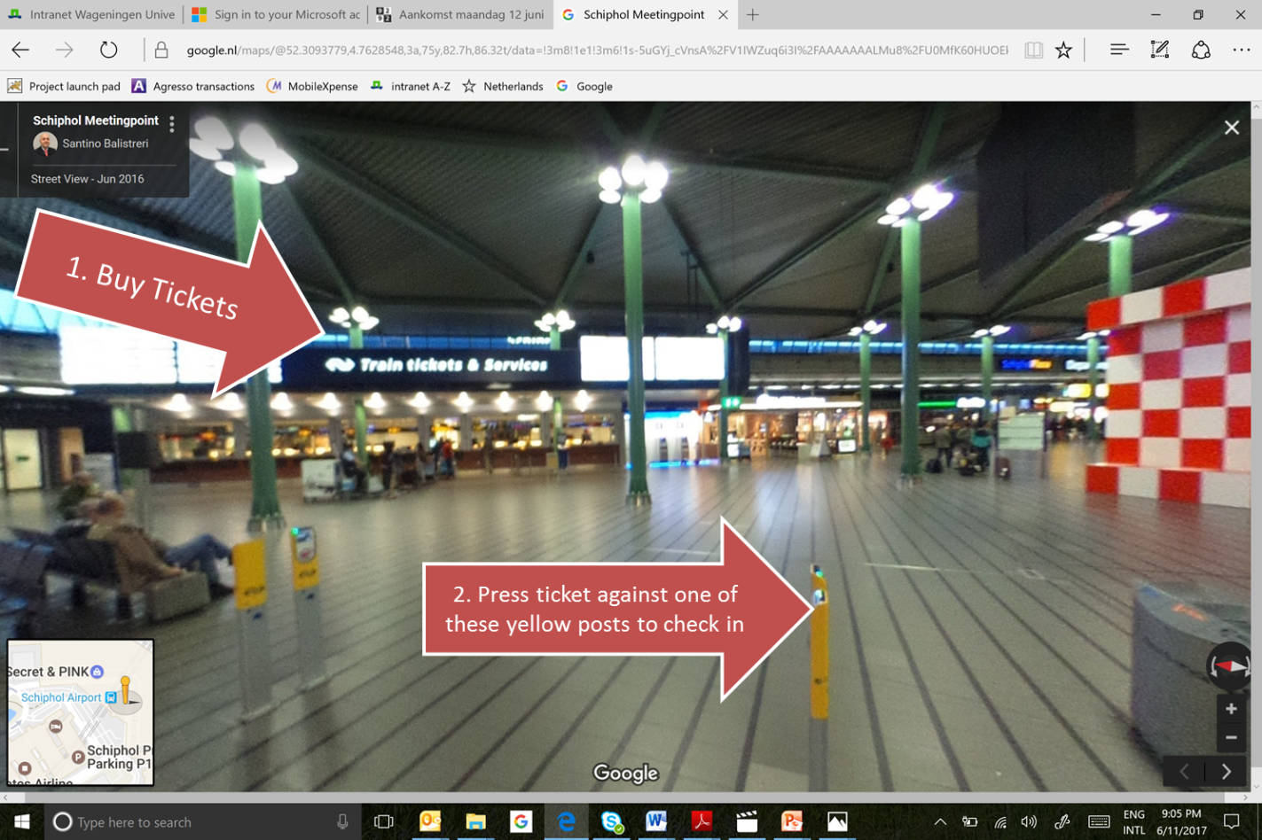

You check-in (= activate your ticket) by pressing it against one of the yellow posts that are dotted around the arrivals hall.

Your train will be the train to Nijmegen (final destination). This almost always leaves from platform 3. The platforms are underneath the arrivals hall.

You leave the train when you reach Station Ede-Wageningen.

Arriving in Ede-Wageningen
Ede-Wageningen station is in between the towns of Ede and Wageningen. From here, you take either a bus or a taxi to your final destination.
To go directly to the WUR campus, take bus 84 or 88.
To go to Hotel De Wageningsche Berg, it is easiest to take a taxi. At the hotel, you can rent a bike to keep you connected with the campus and town.
To go to B&B De Willemshoeve, take bus 86
To go to Wageningen Town, take either bus 84, 86, 88.
You can buy a ticket in the bus. Make sure to have some small change (notes of 50 euro may not be accepted in the bus)
